Experiment No. 7

Aim: Create a simple HTML “Hello World” Project using AngularJS Framework and apply ng-controller, ng-model and expressions.

Theory:

Introduction to AngularJS

AngularJS is an open-source front-end framework developed by Google to create dynamic and interactive web applications. It extends HTML by adding features like data binding, dependency injection, and modular development.

Key features of AngularJS include:

- Two-way data binding: Synchronizes the model and view automatically.

- Directives: Extends HTML functionality with custom elements and attributes.

- MVC (Model-View-Controller) architecture: Organizes code for better maintainability.

- Dependency Injection: Manages dependencies efficiently.

- Expressions: Allows dynamic data binding within HTML.

Understanding ng-controller, ng-model, and Expressions

- ​ng-controller

The ng-controller directive in AngularJS is used to define a controller in an application.

  - Controllers are JavaScript functions that manage data and behavior for a specific part of the application.
  - They are responsible for initializing variables and defining functions that can be accessed in the HTML view.
  - The controller connects the model (data) and view (HTML) through $scope, which holds application data.

​ng-model

The ng-model directive binds input fields (such as textboxes) to application data.

  - It enables two-way data binding, meaning changes in the input field reflect in the model and vice versa.
  - It is commonly used in forms, search bars, and interactive UI components.

​AngularJS Expressions ({{ }})

Expressions in AngularJS are used to bind data dynamically inside the view.

  - They work similarly to JavaScript expressions but are evaluated within the AngularJS framework.
  - AngularJS expressions do not support control flow statements like if or for, but they support mathematical operations and function calls.

Step-by-Step Guide to Build the Website:- Step 1: Set Up Your Project Directory
- Create a Project Folder: Create a new folder on your computer for your project. You can name it HelloWorldAngularJS.
- Create a Directory Structure like below:
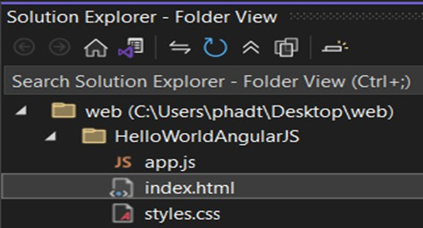

Step 2: Create the HTML File

  - Create an HTML File: Inside your project folder, create a file named index.html.
  - Add Basic HTML Structure: Open index.html in a text editor and add the following

code:

<!DOCTYPE html>
<html lang="en">
<head>
<meta charset="UTF-8">
<meta name="viewport" content="width=device-width, initial-scale=1.0">
<title>Hello World with AngularJS</title>
<link rel="stylesheet" href="styles.css">
<script src="https://ajax.googleapis.com/ajax/libs/angularjs/1.8.2/angular.min.js"></script>
</head>
<body ng-app="helloWorldApp" ng-controller="HelloWorldController">

<div class="container">
<h1>Welcome to AngularJS!</h1>
<h2>{{ greeting }}</h2>

<input type="text" ng-model="userName" placeholder="Enter your name" />
<button ng-click="updateGreeting()">Say Hello</button>

<h3 ng-if="userName">Hello, {{ userName }}!</h3>
</div>

<script src="app.js"></script>
</body>
</html>

Step 3: Create the AngularJS Application File

- Create a JavaScript File: In the same project folder, create a file named app.js.
- Add AngularJS Code: Open app.js in your text editor and add the following code:

// app.js
var app = angular.module('helloWorldApp', []);

app.controller('HelloWorldController', function ($scope) {
$scope.greeting = "Hello World!";
$scope.userName = "";

$scope.updateGreeting = function () { if ($scope.userName) {
$scope.greeting = "Hello, " + $scope.userName + "!";

} else {
$scope.greeting = "Hello World!";
}
};
});

Step 4: Create the CSS File

- Create a CSS File: In the same project folder, create a file named styles.css.
- Add Styles: Open styles.css in your text editor and add the following code:

/* styles.css */ body {
font-family: Arial, sans-serif; background-color: #f4f4f4; color: #333;
text-align: center; padding: 50px;
justify-content: center; align-items: center; height: 100vh; display:flex;
}
.container { background: white; border-radius: 8px; display: inline-block;
box-shadow: 0 4px 20px rgba(0, 0, 0, 0.2); /* Shadow effect */ padding: 40px; /* Padding inside the box */
text-align: center; /* Center text */
width: 300px; /* Fixed width for the square shape */
}
h1 {
color: #007BFF;
}
input[type="text"] { padding: 10px; margin: 10px 0; border: 1px solid #ccc; border-radius: 4px; width: 200px;
}
button {
padding: 10px 15px; background-color: #007BFF; color: white;

border: none; border-radius: 4px; cursor: pointer;
}
button:hover {
background-color: #0056b3;
}
h3 {
color: #28a745;
}
Output:

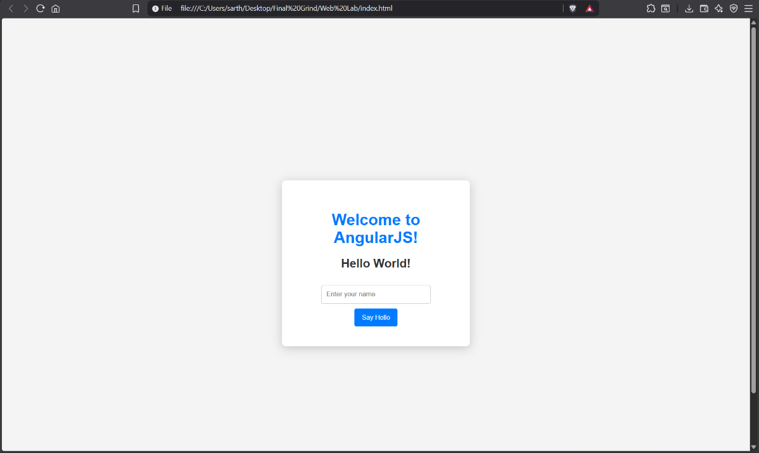
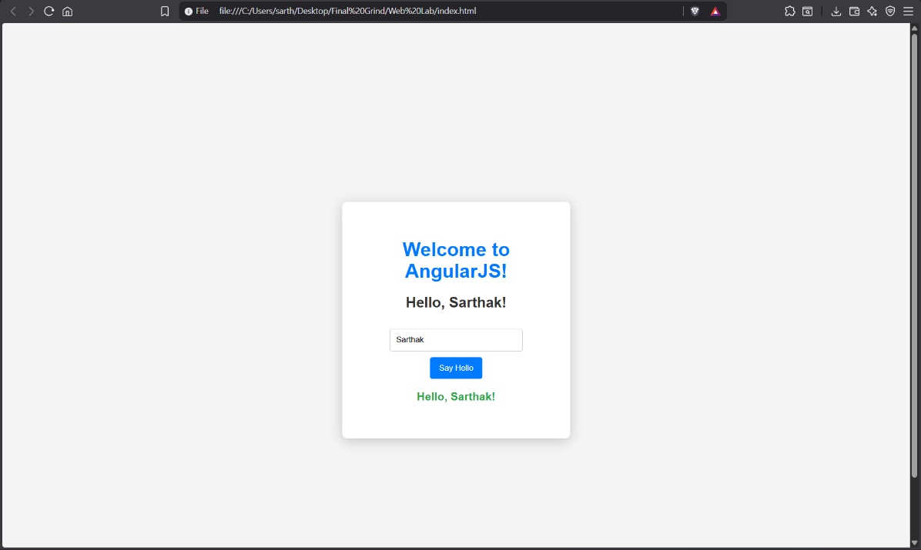

Conclusion:

AngularJS simplifies web development by introducing concepts like ng-controller, ng-model, and expressions. These features allow developers to create dynamic, interactive, and user-friendly applications without manually updating the DOM. By leveraging two-way data binding, AngularJS makes it easier to build applications that respond to user input in real time.

